**DAILY ONLINE ACTIVITIES SUMMARY**

|  |  |  |  |  |  |  |  |  |
| --- | --- | --- | --- | --- | --- | --- | --- | --- |
| **Date:** | **08/06/2020** | | | | | **Name:** | **POOJA D S** | |
| **Sem & Sec** | **4th SEM 'B' Section** | | | | | **USN:** | **4AL18CS056** | |
| **Online Test Summary** | | | | | | | | |
| **Subject** | | **Complex Analysis, Probability and Statistical Methods** | | | | | | |
| **Max. Marks** | | **30** | | **Score** | | | **22** | |
| **Certification Course Summary** | | | | | | | | |
| **Course** | **Introduction to Cyber security** | | | | | | | |
| **Certificate Provider** | | | **Great learning Academy** | | **Duration** | | | **5.5 hour** |
| **Coding Challenges** | | | | | | | | |
| **Problem Statement:** A user will input two strings, and we find if one of the strings is a sub sequence of the other. Program prints “yes” if either the first string is a sub sequence of the second string or the second string is a sub sequence of the first string. Assume that, the length of the first string is smaller than or equal to the length of the second string. Assume that, the length of the first string is smaller than or equal to the length of the second string. | | | | | | | | |
| **Status: completed** | | | | | | | | |
| **Uploaded the report in Github** | | | | | **yes** | | | |
| **If yes Repository name** | | | | | <https://github.com/dspooja/Java-coding>  <https://github.com/dspooja/C-coding> | | | |
| **Uploaded the report in slack** | | | | | **yes** | | | |

Online Test Details: (Attach the snapshot and briefly write the report for the same)

Certification Course Details: (Attach the snapshot and briefly write the report for the same)

Coding Challenges Details: (Attach the snapshot and briefly write the report for the same)

ONLINE TEST DETAILS:

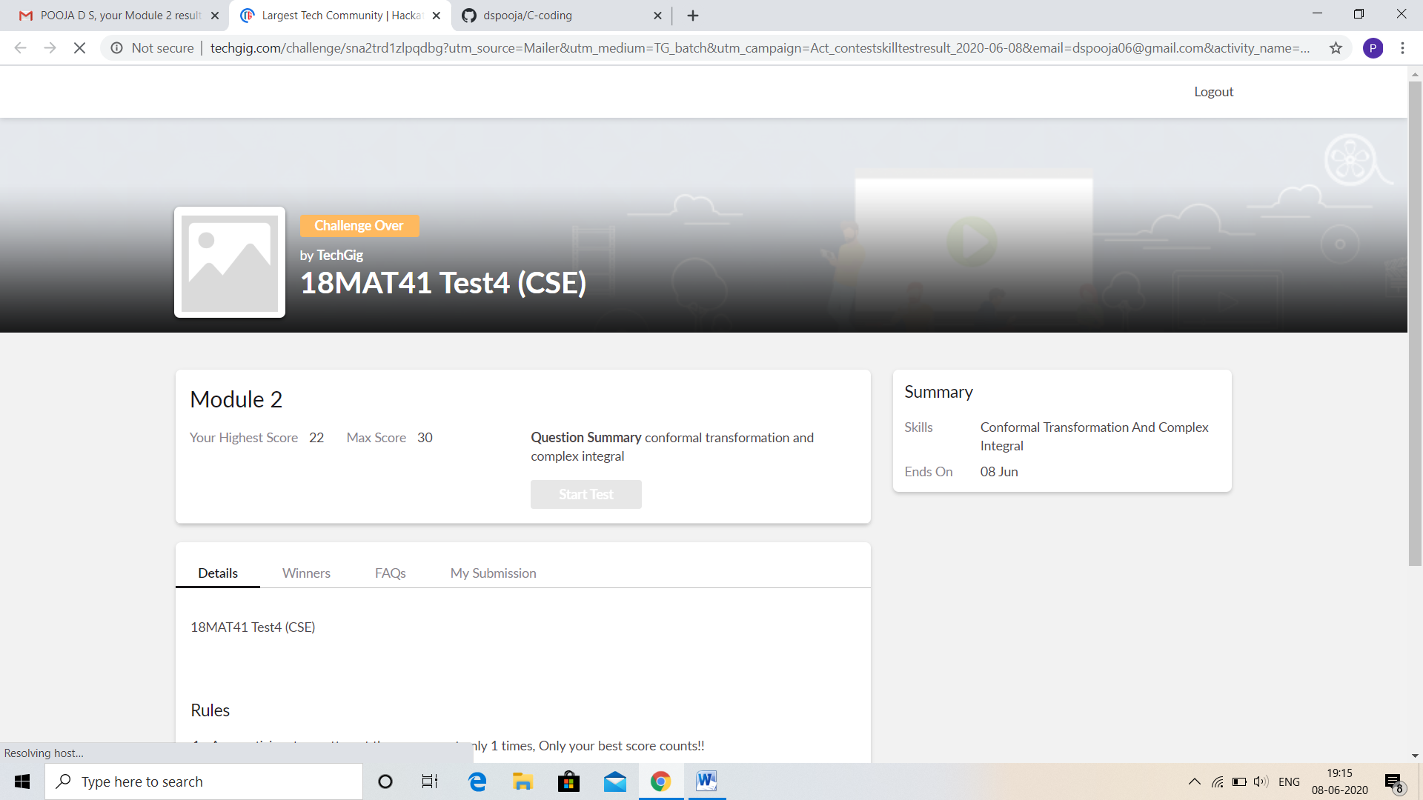

CERTIFICATION COURSE DETAILS:

* As continuation of the **Introduction to Cyber security** online course**.**
* **The concepts covered in Introduction to Cyber security are:**
* Governance and Risk

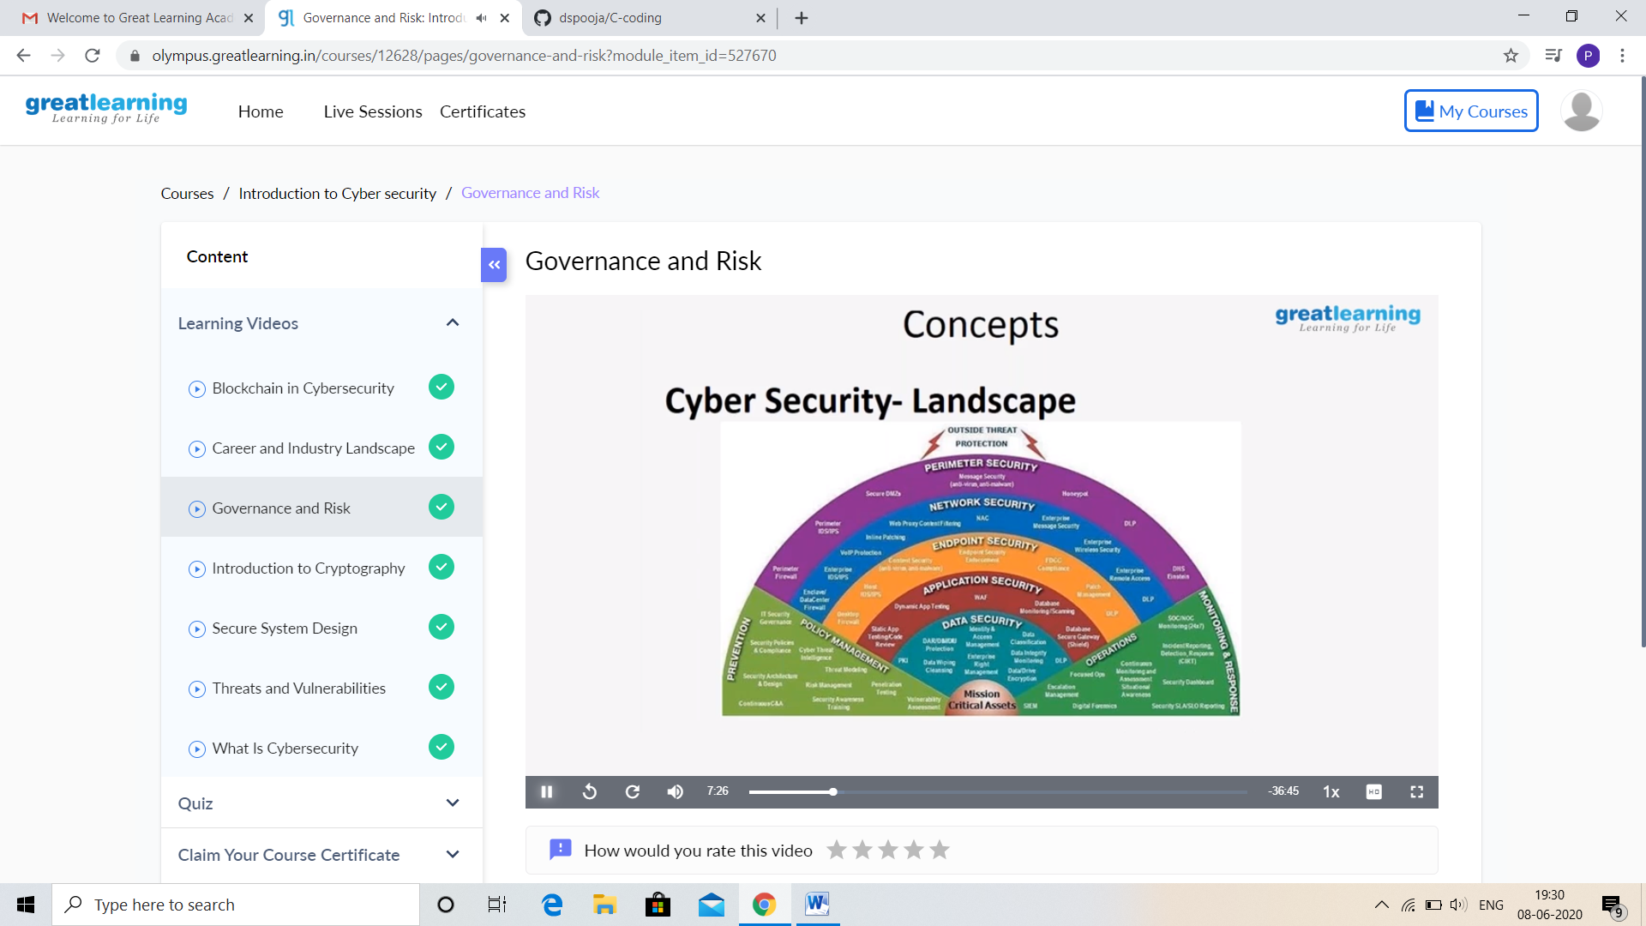

Today I complete only one video its 44 minutes. After I attend IIDE E-Commerce 101 from 11AM to 1PM.

CODING CHALLENGES DETAILS:

Problem statement 1:

Write a Java Program to check whether the given matrix is magic square or not.

Given a matrix, check whether it’s Magic Square or not. A Magic Square is a n x n matrix of distinct element from 1 to n2 where sum of any row, column or diagonal is always equal to same number.

Examples:

Input: n = 3  
2 7 6  
9 5 1  
4 3 8  
Output: Magic matrix  
Explanation: In matrix sum of each  
row and each column and diagonals sum is  
same = 15.

Input: n = 3  
1 2 2  
2 2 1  
2 1 2  
Output: Not a Magic Matrix  
Explanation: In matrix sum of each  
row and each column and diagonals sum is  
not same.

Solution: Uploaded in github.

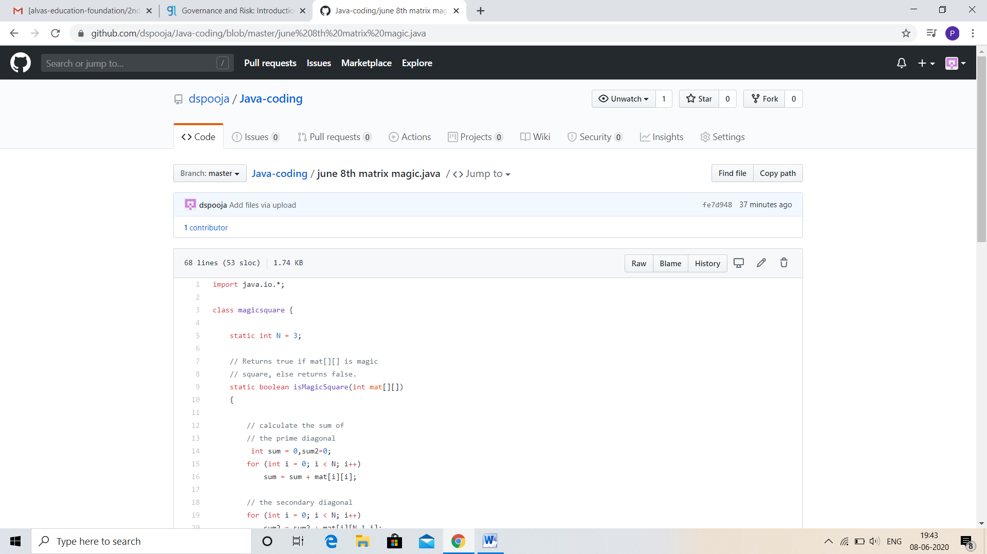

Problem statement 2:

C Program to Generate All the Set Partitions of n Numbers Beginning from 1 and so on.

This algorithm partitions an integer into numbers which sum up to form the original number. It generates partitions of a set of numbers for a given range.

**Sample Input**

Enter a number N to generate all set partition from 1 to N: 5  
Integer partition for 1 is:  
1

Integer partition for 2 is:   
2  
11

Integer partition for 3 is:   
3  
12  
111

Integer partition for 4 is:   
4  
13  
112  
1111  
22

Integer partition for 5 is:   
5  
14  
113  
1112  
11111  
122  
23

Solution: Uploaded it in github

